**1.Create VPC**

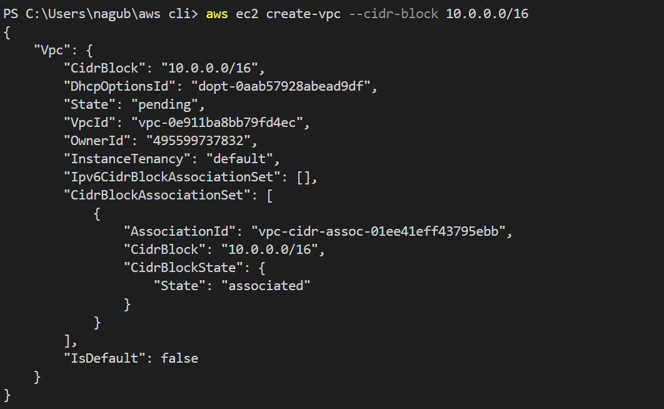

**2. Create 6 subnets(3-public, 3-private)**

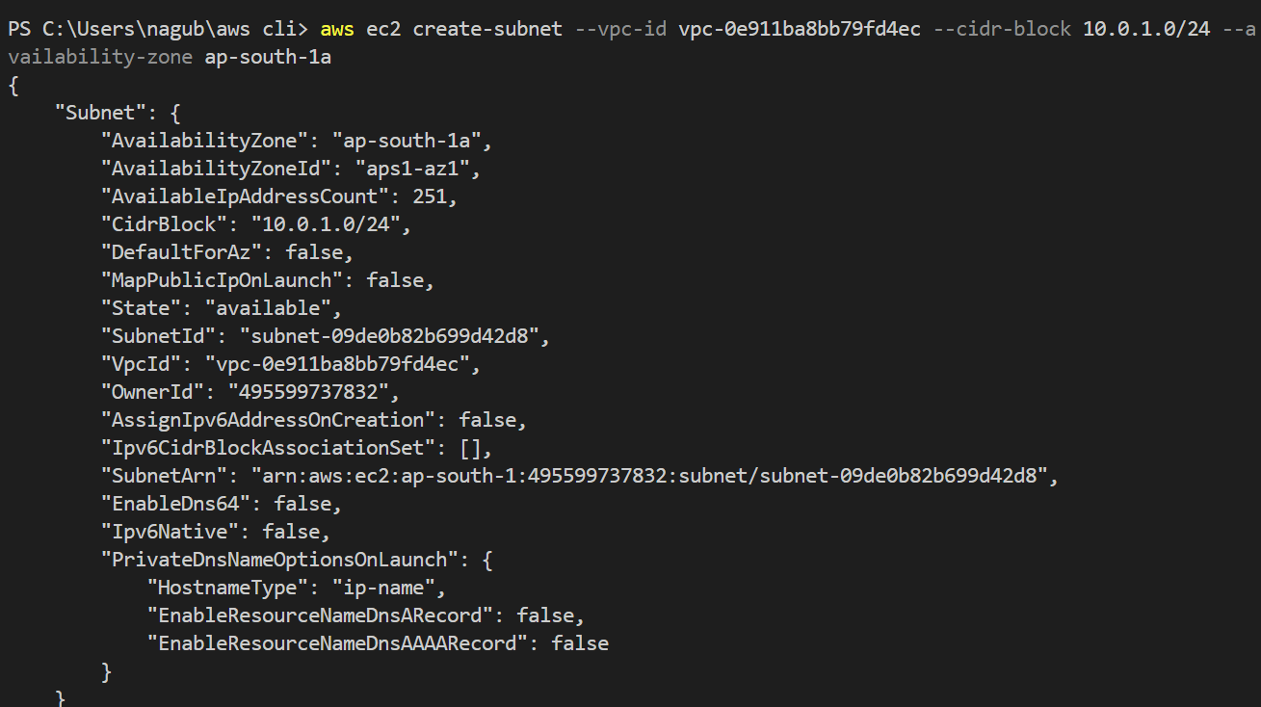

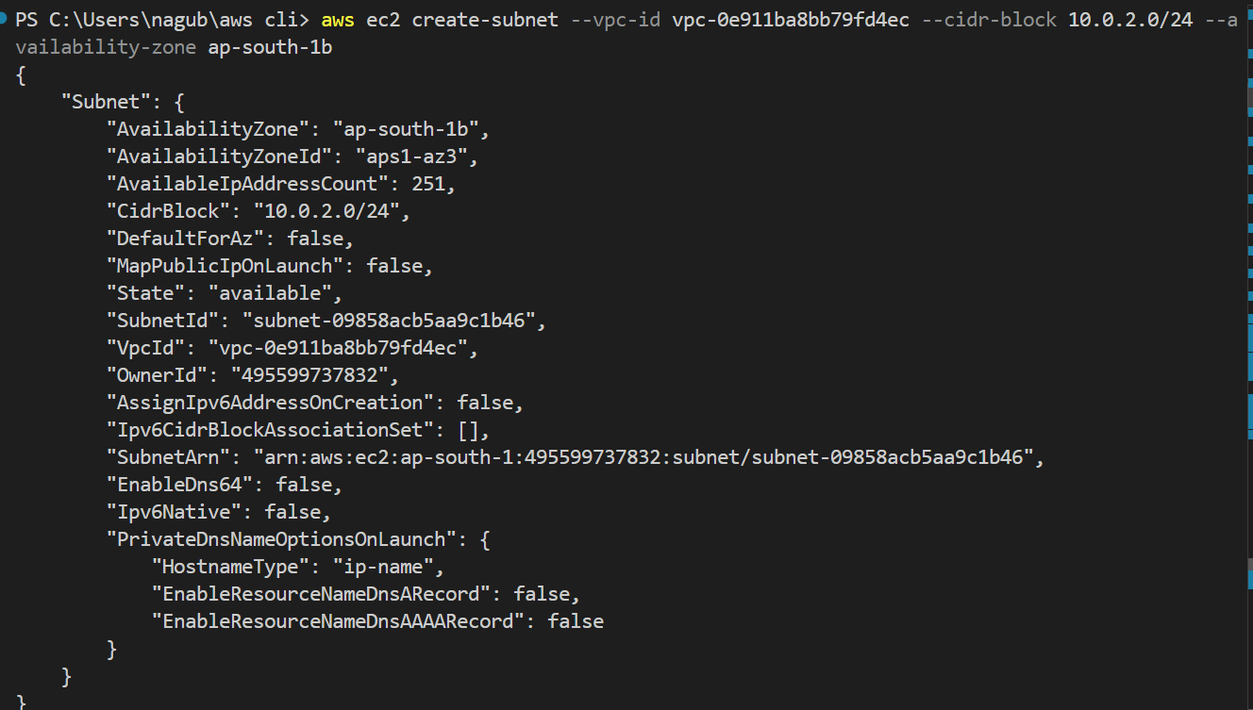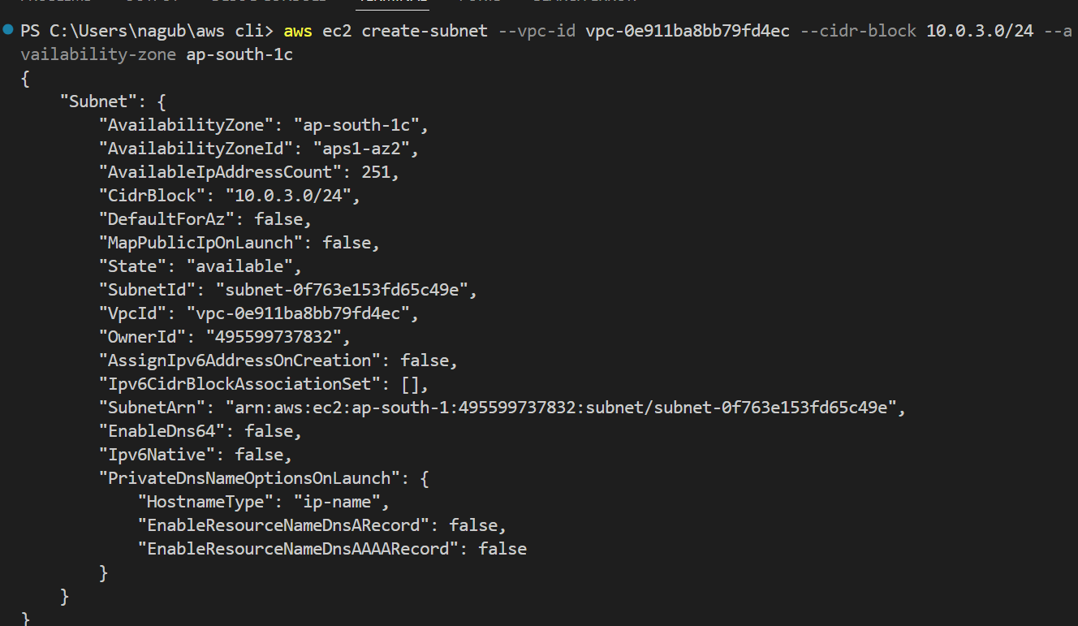

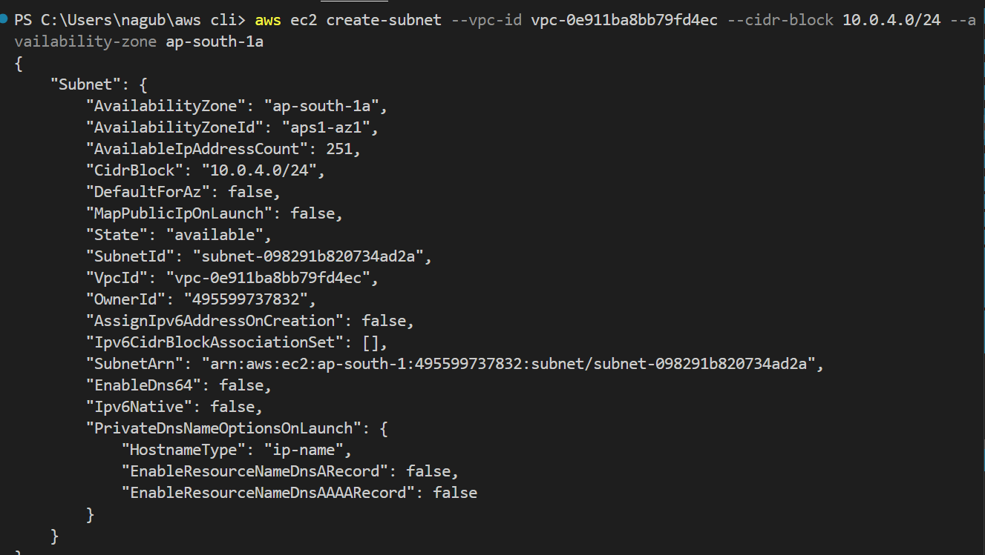

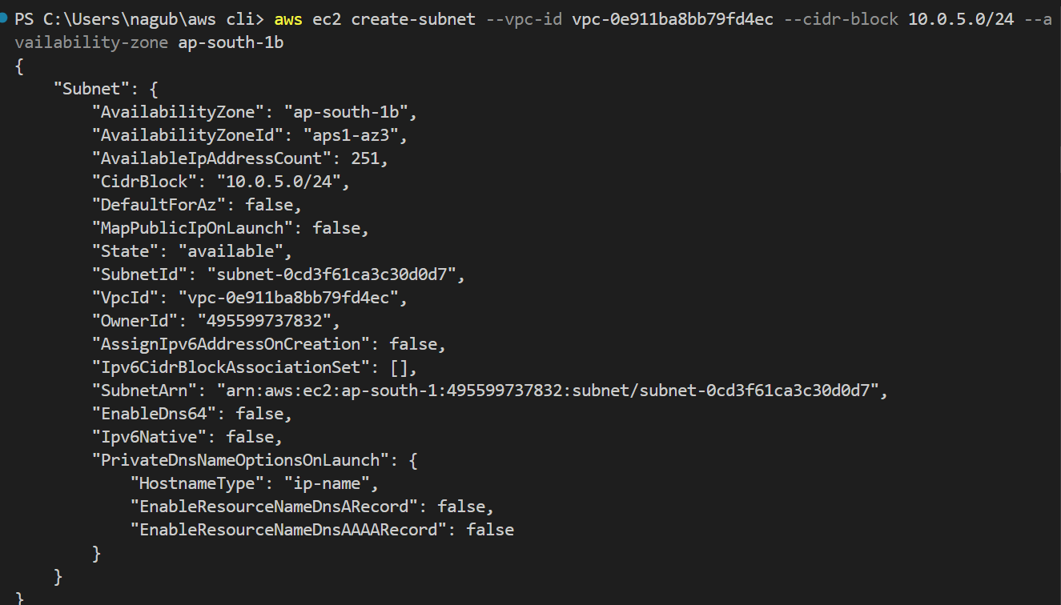

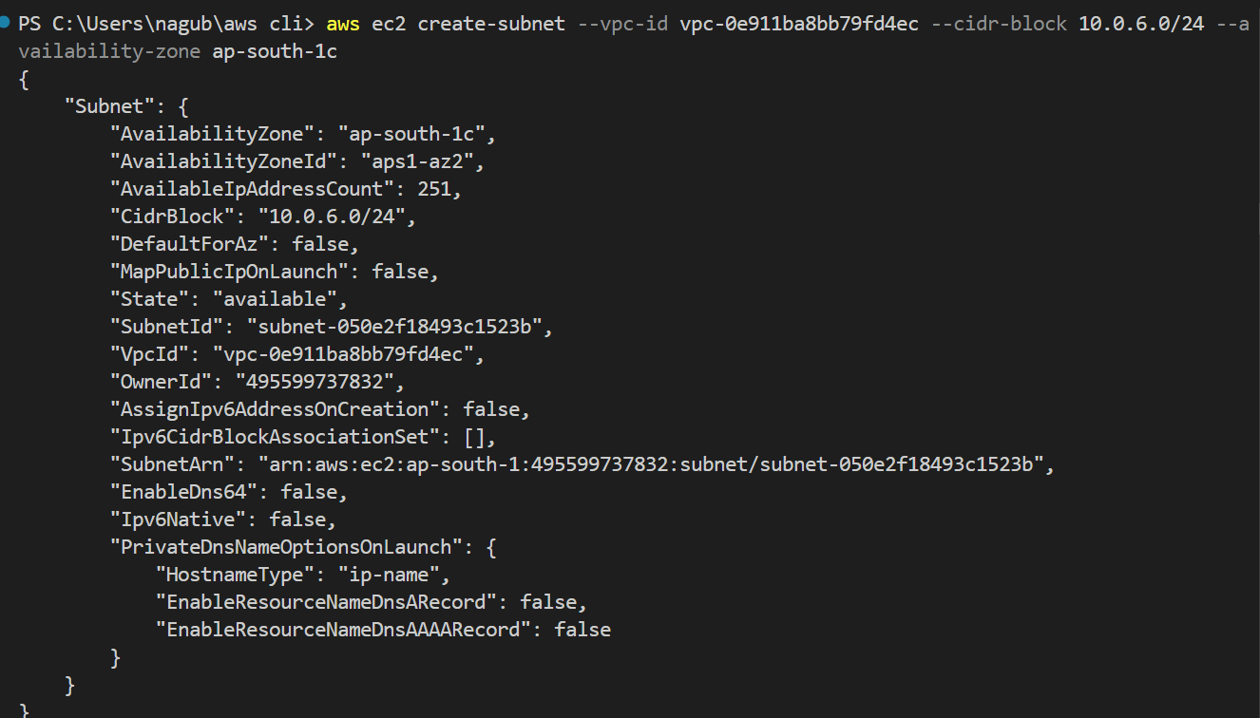

**3. Create public and privtae route tables**

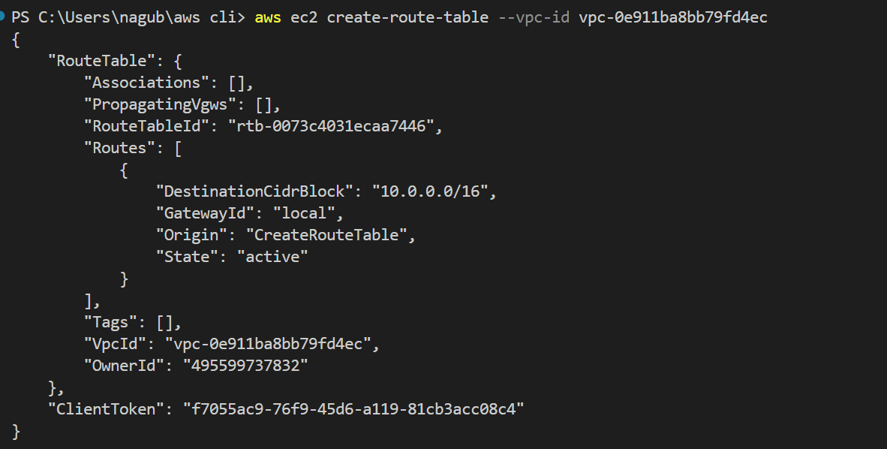

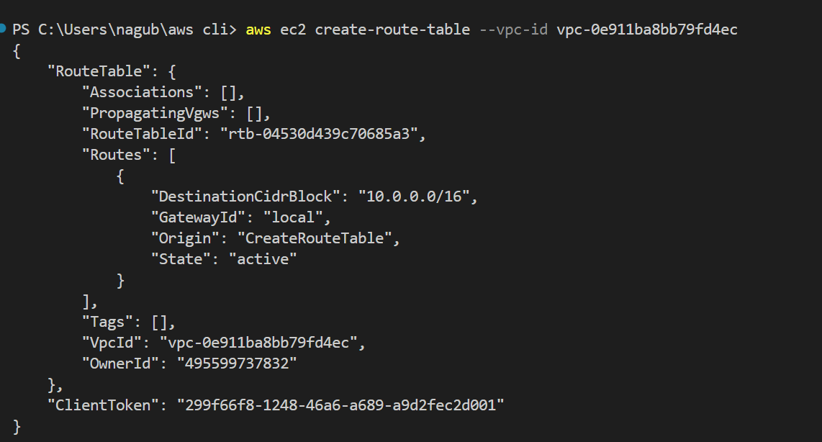

**4. Create IGW**

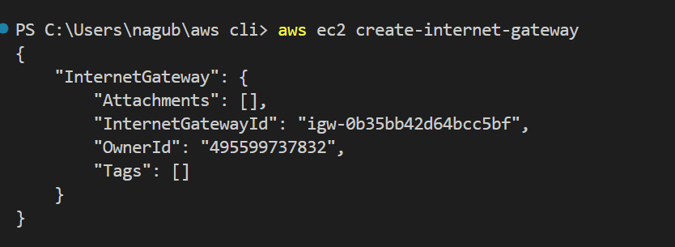

**5. Attached IGW to VPC**



**6. Add route to public-route-table(to send traffic via IGW)**

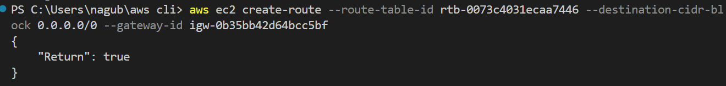

**7. Associate all 3 public-subnets to public-route-table**

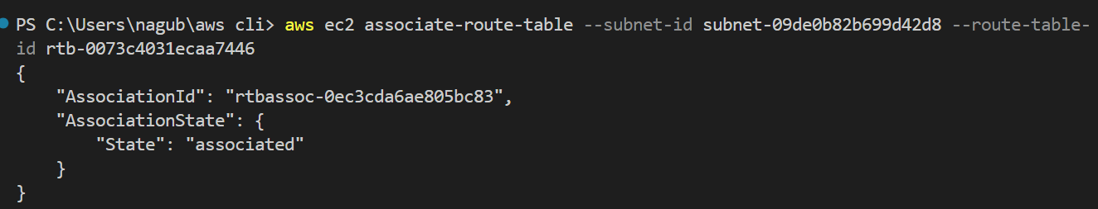

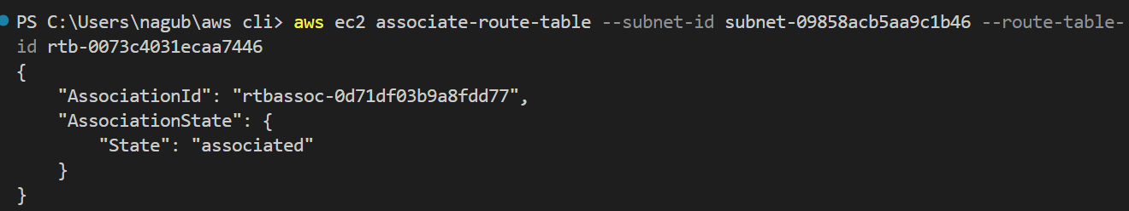

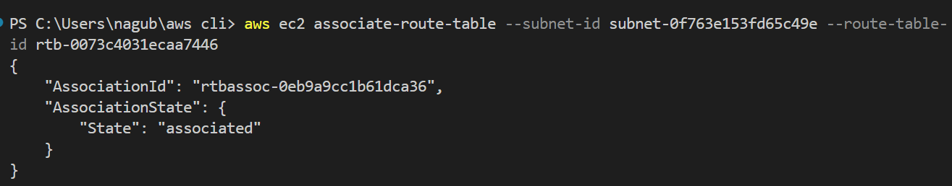

**8. Create NGW along with elsticIP**

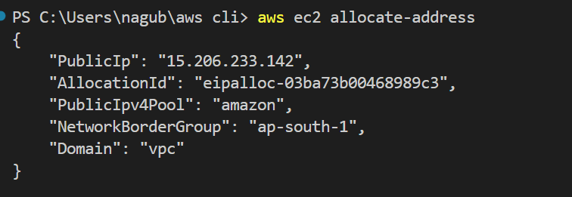

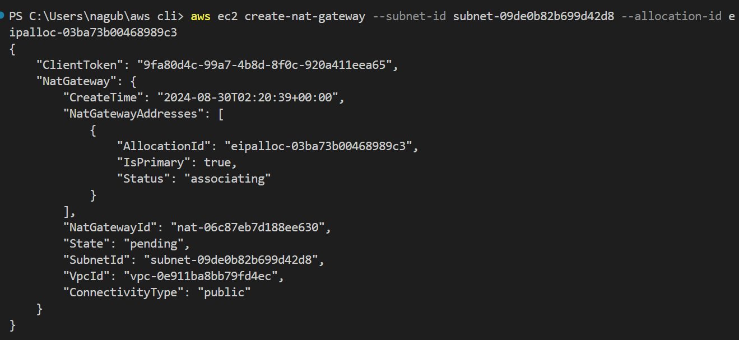

**9. Add route to private-route-table(to send traffic via NGW)**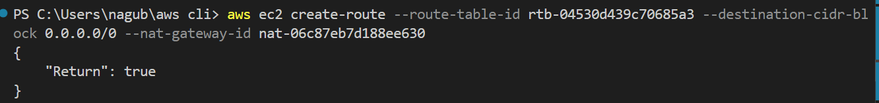

**10. Associate all 3 private-subnets to private-route-table**

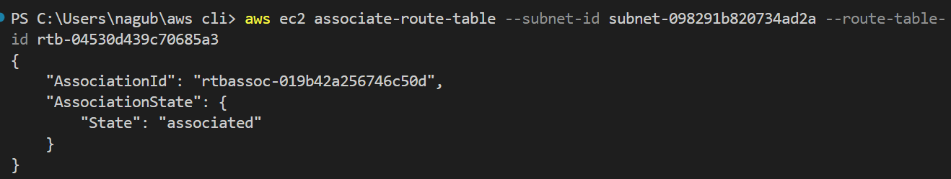

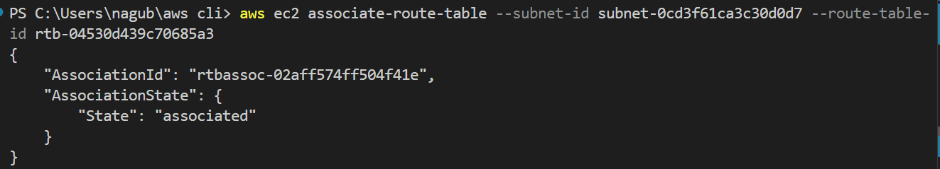

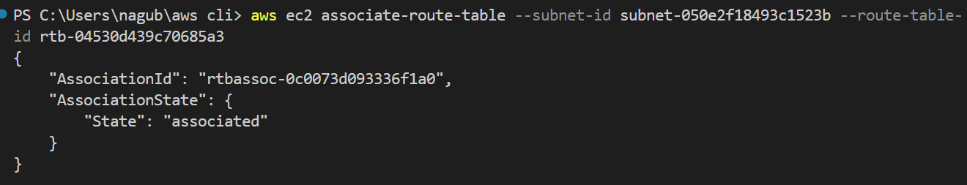

**11. launch an ec2 instance in public subnet**

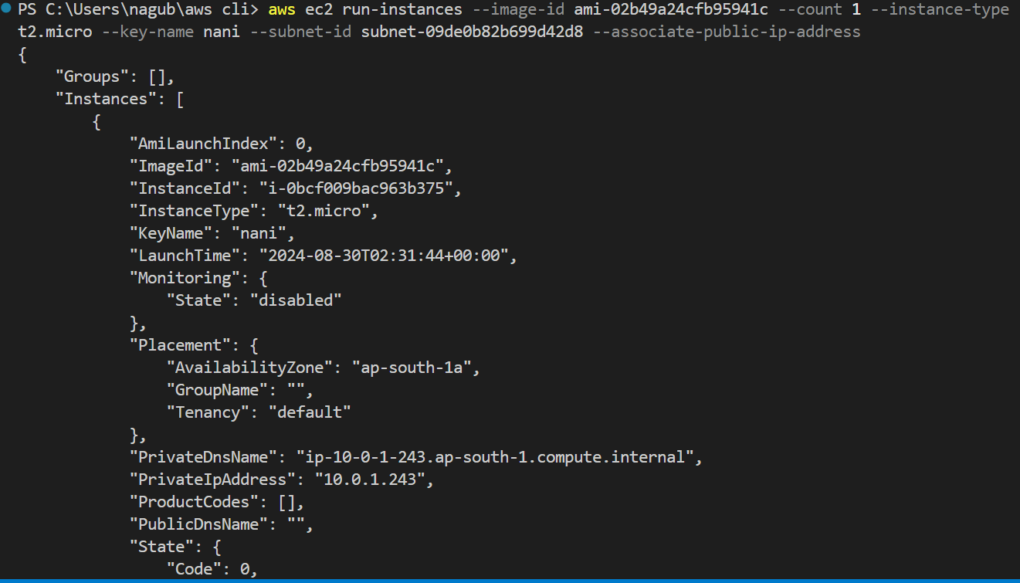

**12. launch an ec2 instance in private subnet**

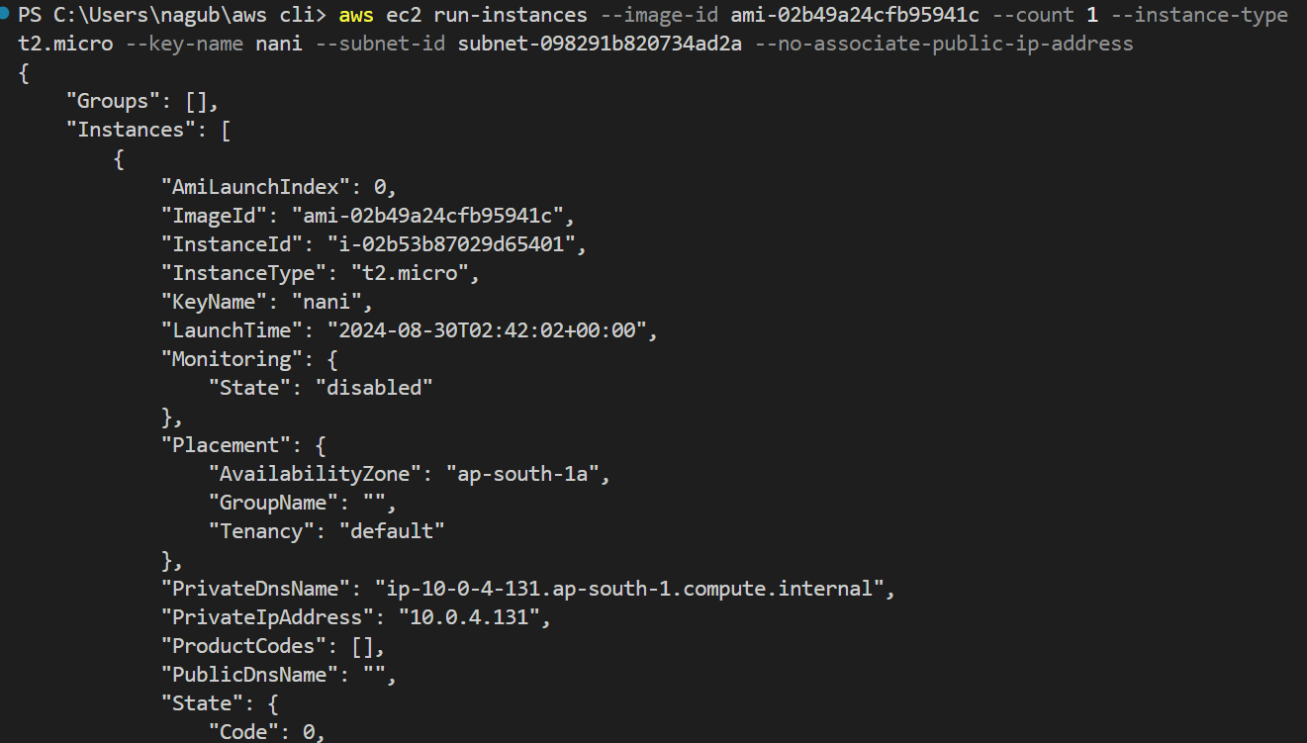

**13. Connect to ec2 instance in public subnet**

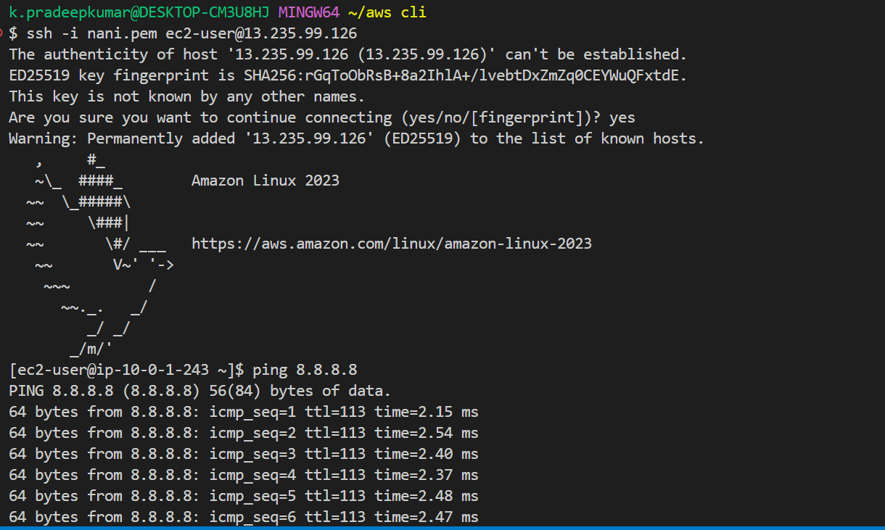

**14. Connect to ec2 instance in private subnet -> check answer**

1)First i connect to ec2-instance in public subnet using mobaxterm

2) upload the pem.file in mobaxterm.

3)and check the pem file is exists or not

4) select the private instance and click on connect and go to SSH client and

5)enter the command**(ssh -i <KeyName>.pem ec2-user@<PrivateInstancePrivateIP>)** and

Add the SSH rule in the security group Click enter

6)and after we get denied permission.

7)After getting denied permission.enter a command(**chmod 400 keyname.pem)** is used for

Change the file permissions.

8)Now enter the **ping 8.8.8.8** command to check whether it is working or not

**15**. **Stop Both EC2 Instances**